# ACCESSING FIRST CHILD

Console.log(document.body.firstChild);

//When we use first child then text nodes count as well. //text nodes are hidden in html

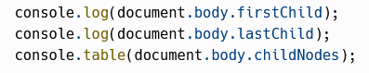

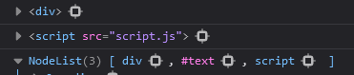

# ACCESSING SIBLINGS

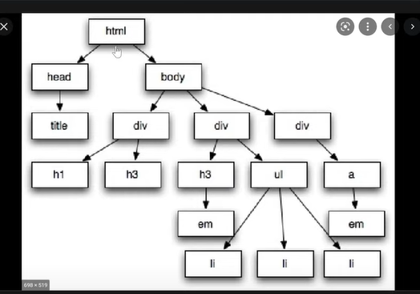

//Body is right or next sibling of head and vice versa

$0.nextSibling

PARENT NODE AND PARENT ELEMENT

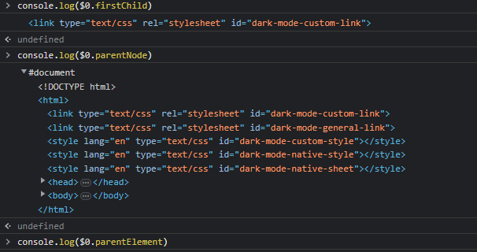

//$0 is html here and here you can tell the difference between parentNode and parentElement

using dot between the child and siblings

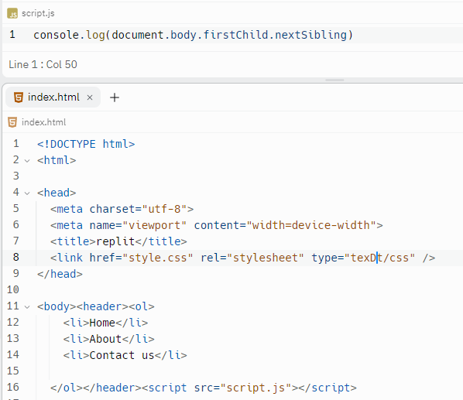

//IT WILL SHOW SCRIPT

//only use element tags

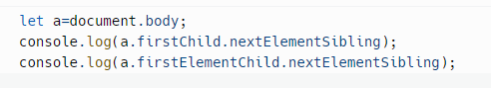

# PRACTICE QUESTION

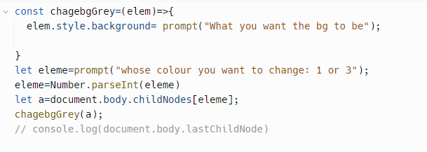

Table Based Navigation

//table links

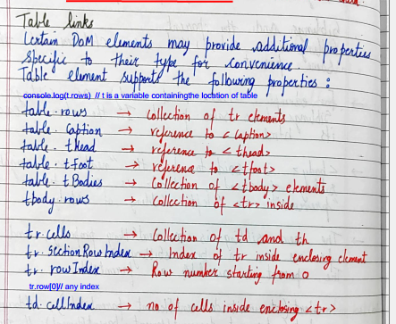

# SEARCHING THE DOM

#36 is the title of the video and it also contains bootstrap as well

//dom navigation like using firstelementCHild and nextSibling etc are helpful when you know where the elements are but if they are far off we use different searching methods which are defined below

# Document.getElementByName

//is only used with input tag



# Example of Getelementsbycalssname

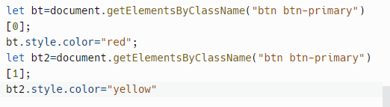

//you can select elements within the elements after using the queryslector and making a variable

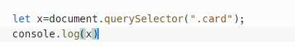



//Use multiple selectors as well



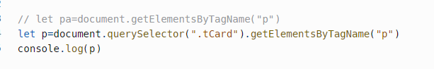

MATCHES , CLOSEST , CONTAINS

# Matches

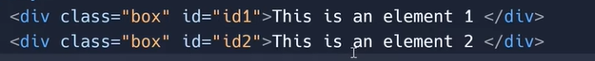

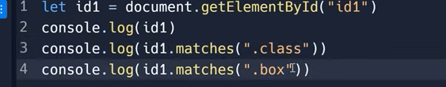

//it will return true and false

# Closest and contains

//checks if the given css selector isin the ancestor of that element or not

